

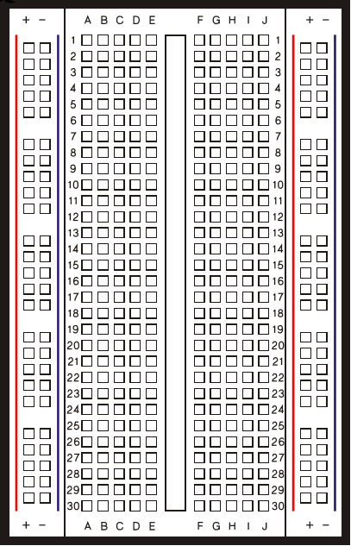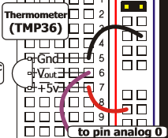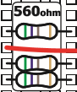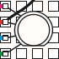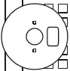



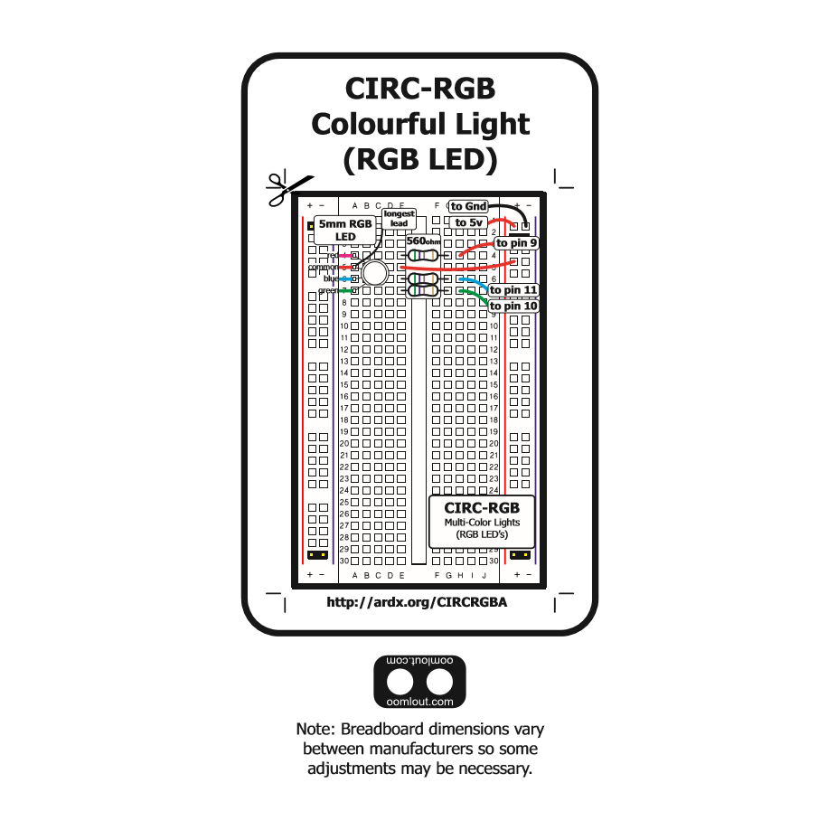

**CIRC-DAB**

**Somewhat Cool Temp Sensor**

**(Designed by: Michael Moldovan, Theo Stangebye, Jacob Eisenhart, Mitchel Miller, & Josiah Talampas**

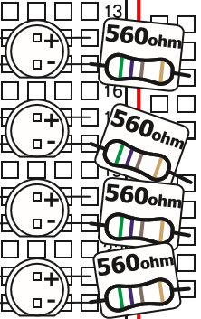

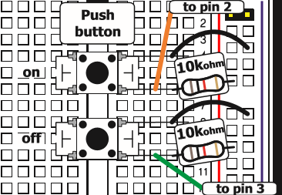









z

z

